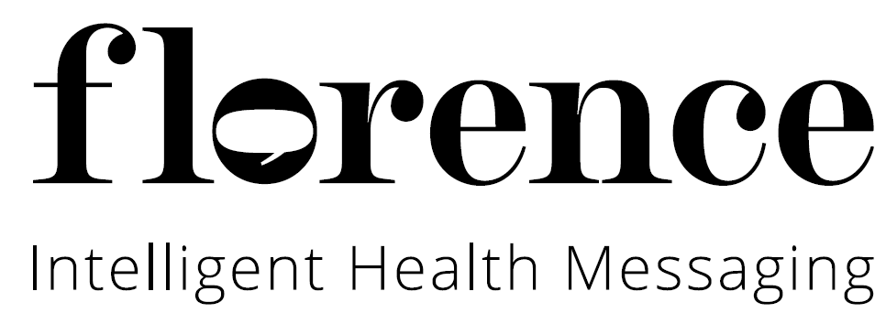
REPLACE WITH LOCAL
NHS LOGO

Patient Suitability Questionnaire

1. Would this patient benefit from reminders? e.g. Medication or Lifestyle
prompts to motivate behaviour change?
Yes □ No □
2. Would this patient benefit from clinical monitoring? e.g. BP, Blood Glucose or Weight?
Yes □ No □
3. Does this patient or their carer /family member have access to a mobile phone?
Yes □ No □
4. Is this patient or their carer /family member already able to use text messaging?
Yes □ No □
5. Does this patient or their carer / family member have the competence/dexterity to learn how to send a text message?
Yes □ No □

If ‘yes’ to all the above, the patient is suitable for Flo. If you find that your patient is a borderline yes to question 5 then consider signing them up to Flo and provide them with the top tips for texting leaflet. It may also be useful to sign the patient up to Flo in the presence of a clinician to confirm that the patient can read and reply to Flo’s invite message.
V1.02

