Date | Time | Reading
Record your readings (optional)

For more information about how Flo is supporting patients across the UK to manage their health better, please visit www.simple.uk.net
Your (condition) Shared Management Plan with Flo
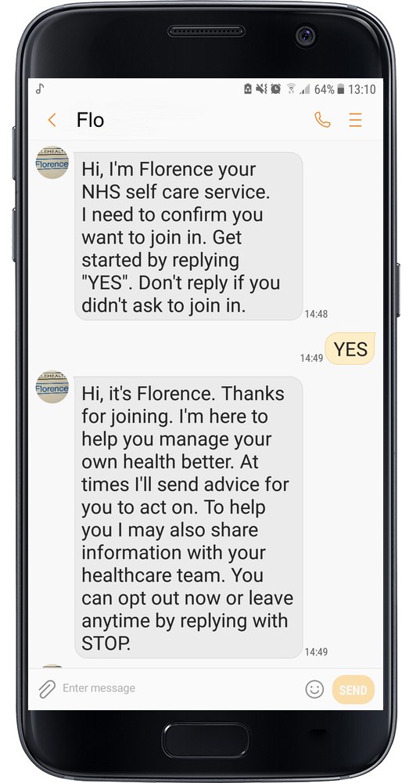
(Add NHS organisation Logo if desired)

Patient name:

Contact Information
(Insert specific contact info for specialist/team/clinic etc)
Reading | Recommended actions
Within target range (specific) | (Reading is normal, so consider adding some encouragement or motivational points. Consider generic advice for the patient’s condition, or other advice for healthy lifestyle.)
Outside target range - advisory (specify) | (Add appropriate advice)
Outside target range – action required (specify) | (Add appropriate advice)
Top Tips for replying to Flo

Here are a few important things for you to remember to help Flo to support you without any problems:
- Try to reply to Flo as soon as you can. Some of Flo’s services allow you to reply at any time, but many will have a time limit for receiving your readings.
- Flo will understand UPPERCASE or lowercase.
- If Flo asks you for more than one reading, you can send them in one text, or separate texts – whichever you find easier.
Flo will reply letting you know that she has received your readings. If you don’t receive acknowledgement reply, please double check:
- Does the text you sent follow the example Flo gave you when she requested your reading?
- Have you accidentally typed the wrong number along with your reading? For example, have you sent BG 56.0 instead of BG 5.6?
If you have checked all of the above, and are still having problems, please get in touch with your (specialist nurse/team/clinic/doctor – add as appropriate) for more support.

Additional Information (change for your use)
(Add any additional clinical guidance you would like to give to the patient here).

